Study Guide for the On-Campus Final for CHM151
Instructor: Ken Costello
The emphasis of this exam covers two areas:
Survival skills for learning chemistry |  |  | Chemistry in a New Light
 | 1. Overcoming misunderstood Words and Symbols |  |  | Building Blocks
 | 2. Overcoming a lack of reality |  |  | Force/Energy
 | 3. Overcoming too steep of a learning curve |  |  | Mathematics

1. Overcoming misunderstood Words and Symbols
Like I forewarned, there was going to be a lot of new words and symbols in this course.
The metric system has own words and symbols. There are several more, but the ones below are commonly used in chemistry. Commit these to memory.
Metric prefix | mega | kilo | deci | centi | milli | micro | nano | pico
English | million | thousand | tenth | hundredth | thousandth | millionth | billionth | trillionth
Exponent | 10⁶ | 10³ | 10⁻¹ | 10⁻² | 10⁻³ | 10⁻⁶ | 10⁻⁹ | 10⁻¹²
Symbol | M | k | d | c | m | μ | n | p
The words and symbols above are all about the same size. The sizes they represent are not even close to the same size. You must have reality of the sizes of the below lengths and be able to draw their approximate sizes.
4 inches
1 decimeter (10 cm)
1 inch
2.5 centimeters
1 centimeter
1/16 inch
1 millimeter
Chemistry deals with real volumes. You also should be able to draw a cubic inch, cubic centimeter (mL), and a cubic decimeter (a liter) or a multiple of any of these.

cubic centimeter (milliliter)
cubic inch
cubic decimeter
1 liter
1000 milliliters

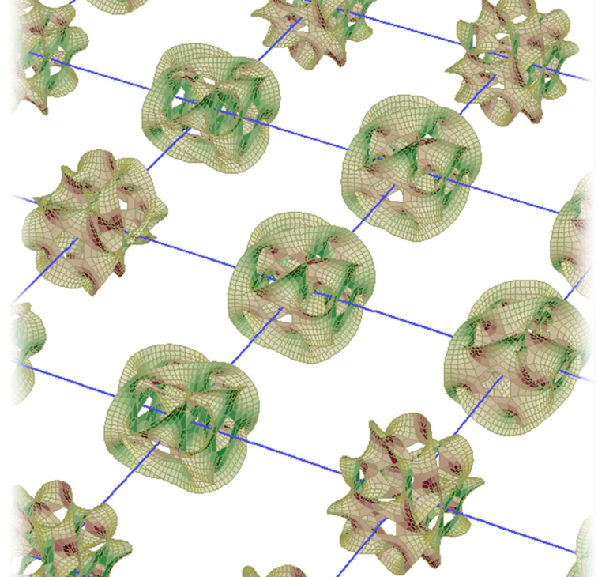
BUILDING BLOCKS
Chemistry is very much about building blocks. The smallest building blocks that have been proposed but not yet proven are strings of energy. These strings are very small and require 13 dimensions, not just 3. The image on the right is a representation of these strings sitting at the very smallest points of space. The extra dimensions sort of wrap upon themselves. The new Large Hadron Collider particle accelerator may actually give some proof to this theory. The collider has been in the news lately breaking new energy records. They will look for particles that simply pop out of existence as they leave our 3 dimensions and go into one of the other 10 dimensions. That will be very exciting news.
These points in space are 1.6 x 10⁻³⁵ meters apart. In math you can take 1.6x10⁻³⁵m and divide by 100 to get 1.6x10⁻³⁷m, but in chemistry that presents a problem because there’s no way to ever see it using light. Light at a small enough wavelength (high enough frequency) to see these points will have so much energy it would create a black hole and disappear. That can be calculated with the formula for light energy, E = hv where v is frequency and h is Planck’s constant. By the way, the distance of 1.6x10⁻³⁵ is called Planck’s length.
Below is a table of the building blocks for chemistry (On the test I will replace red words with blanks that you fill in).
 |  | Strings of Energy
 |  | Protons | Neutrons | Electrons
Element: Atoms with same # of protons |  |  | Atom | Ion: (atom with +/- charge)
Compounds: (2 or more different atoms (elements) with ionic or covalent bonds) Examples: H₂O, NaCl, CH₄ |  | Molecule: (2 or more atoms that can be same or different): Examples: O₃, H₂O, NaCl, CH₄ |  | Polyatomic ions: (2 or more different atoms with net +/- charge) Examples: SO₄²⁻, NH₄⁺, NO₃⁻
Macromolecule: (chains of smaller molecules) Examples: starch, cellulose, protein, DNA, polymers |  | Ionic crystals: (stacks of + & - ions) Examples: NaCl, CaF₂, MgO, K₂CO₃ |  | Network solids: (stacks of non-metal atoms covalently bonded) Examples: diamond, SiC, quartz=SiO₂ |  | Molecular solid: stacks of small molecules) Examples Ice, dry ice, sugar, Aspirin
Force and Energy
The main forces in chemistry are electromagnetic forces, which include electrical, magnetic, and light forces. The atom exists because of electrical attraction between the protons in the nucleus and the electrons around it. Molecules exist because atoms have electrical attraction to neighboring atoms. The building blocks above are all created through electrical attraction and repulsion. Chemical reactions are almost entirely based on electrical attraction and repulsion. For example, to understand the body, understand how chemicals in the body either attract or repel each other. The situation where carbon monoxide is poisonous because it has a stronger electrical attraction to red blood cells than oxygen does. Also, muscle contraction is dependent upon the electrical attraction and repulsion forces of calcium (Ca²⁺), sodium (Na⁺), and potassium (K⁺).

Below is a table that describes the Electromagnetic forces that relate to chemistry.
Electromagnetic Forces
Electrical | Magnetic | Light
Repulsion of like charges (proton repel protons, electron repel electrons, ions with like charges repel) Examples: protein shapes, VSEPR=Valence Shell Electron Pair Repulsion, electron orbital shapes, air pressure.  Attraction of unlike charges (protons/electrons, + /- ions) Examples: all bonds, protein shapes, nearly all chemical reactions, London Dispersion forces | Magnetism pushes on any moving charge such as electrons, protons, and all ions. Examples: Instruments based on magnetism: mass spectrometer, NMR, & MRI. Magnetism affects electron orbital shapes. Unpaired electrons in atoms make materials magnetic. | Radio waves move electrons (antenna) and moving electrons create radio waves (transmitter). High frequency radio waves vibrate molecules (microwave oven). Infrared light stretches bonds and vibrates molecules (heat lamp). Visible light pushes electrons to higher orbitals. This gives items color and allows photosynthesis . UV light breaks bonds (sunburn).  X-rays are diffracted by crystals and also break bonds.
On the test I will leave out the words in red. Also, I will ask what does NMR and MRI stand for.
Survival Skill of overcoming a lack of reality. The above table is all words. Let’s give it some reality.
Clap your hands. Technically your hands never touch. The repulsion of electrons in the proteins in your skin repelled each other, keeping the surface of the hands from touching. What you felt was electrical repulsion and not the hands themselves. This repulsion also pushed on the electrons in the air molecules between your hands, which squeezes the air molecules together. The outer electrons of the compressed air molecules create a chain reaction of repulsion on the electrons of other air molecules. This is how sound gets to your ears. Sound, voice, and music are all the result of electrons repelling electrons.
What allows the chair you are sitting on to hold you up? The electrons in the chair’s surface are repelling the fabric on the seat of your pants. Also, the strength of the chair is the attraction of protons and electrons between atoms. In other words the bonds between atoms give it strength.
Electrons absorbing light give us vision. Find something blue or green to look at. Now learn the chemistry happening in your eye. A modified form of Vitamin A gets attached to a protein called Rhodopsin. See image below. When blue-green light (represented by hv, which is the energy of the light calculated by Planck’s constant times frequency) hits the pi bond in the double bond shown, it breaks the pi bond momentarily allowing the right end of the molecule to swing around. The pi bond reforms but now the right end has rotated. This new molecule sets off a signal and allows you to see blue-green colors.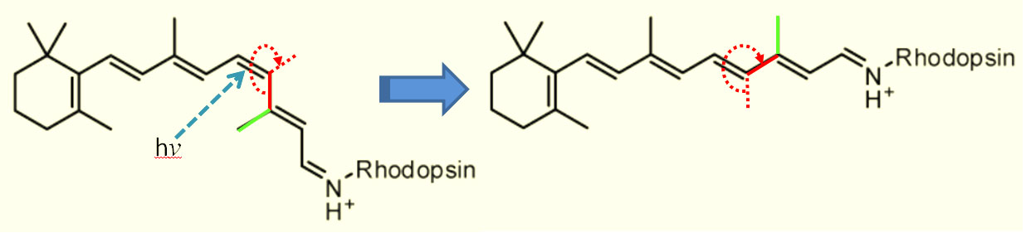On the test I will show the molecule before light hits it. You will draw the final molecule (right side).

Force and energy go together because whenever a force causes a movement that requires or releases energy. Let’s look at how these various forms of energy relate to chemistry.
ENERGY
Mechanical | Potential | Kinetic/Heat | Heat of Reaction | Light
Force x distance= work energy. Pressure (force) of gas times distance it expands (volume change) is work energy. | For objects, more potential energy means higher above the ground. For atoms, it means separating charges more, i.e., electrons or negative ions are moved farther away from protons or positive ions. | Kinetic energy is the energy from movement. The kinetic energy of a collection of atoms or molecules is its heat energy (enthalpy). Heat Capacity is heat energy per gram, lb., or mole. Specific Heat is Heat Capacity per °C or °F. When substances change from solid to liquid to gas, the atoms or molecules change speed, so heat energy changes. Energy from these phase changes are called Heat of Fusion (liquid>solid) and Heat of Vaporization (liquid>gas). | As elements combine to make compounds, energy is released, which is called Heat of Formation. As compounds react, energy may be released (exothermic) or absorbed (endothermic). That’s called Heat of Reaction.  If reacting with oxygen, then it is called Heat of Combustion. | Energy of light is based on its frequency (or wavelength). The formula is E=hv. Where “v” is frequency and h is Planck’s constant.
Electrical
Electrical power is watts. Watts times seconds gives us energy in joules.
On the test I will substitute the words in red above with blanks. You fill in the missing word.
Mathematics

My biggest advice for mathematics is to learn dimensional analysis and do it using spreadsheets. In upper levels of chemistry, you will be required to use spreadsheets, but take advantage of this technique now. The below problems are worked out. You will just need to decide where the units go. On the final exam, the units (dimensions) or values that are red will be replaced with blanks that you fill in. You don’t need to memorize what they are. Just figure out what needs to be there in order to give the answer the correct units. You will not need a calculator.
 | A | B | C | D | E | F | G | H | I | J | K
1 | Starting grams given |  | NaOH Molar mass g>moles |  | Ratio from balanced equation |  | Turn moles Na₂SO₄ to grams |  |  | Grams asked for
2 | 5.00 | grams NaOH | 1 | mole NaOH | 1 | mole Na₂SO₄ | 142 | grams Na₂SO₄ | = | 8.88 | grams Na₂SO₄
3 |  |  | 40.00 | grams NaOH | 2 | moles NaOH | 1 | mole Na₂SO₄

 | A | B | C | D | E | F | G | H | I | J
1 | Concentration in g/100mL times its mL gives grams of HNO3 |  |  |  | Ending 5% w/v inverted |  |  |  | Final volume
2 | 70.0 | g HNO3 | 200 | mL solution | 100 | mL | 0.001 | = | 2.80 | Liters
3 | 100 | mL solution |  |  | 5 | g HNO3 | milli

 | A | B | C | D | E | F | G | H | I | J | K | L | M
1 | Moles/Liter times Liters gives moles of HNO3 |  |  |  |  | molar mass HNO3 |  | Ending 5% w/v inverted |  |  |  | Final volume
2 | 15.7 | moles | 200 | mL | 0.001 | 63.01 | grams | 100 | mL | 0.001 | = | 3.97 | Liters
3 | 1 | L |  |  | milli | 1 | mole | 5 | g HNO3 | milli

 | A | B | C | D | E | F | G | H | I
1 | 5g/100mL times 473mL gives grams |  |  |  | Density of pure acetic acid is 1.049g/mL |  | pure acetic acid
2 | 5 | g | 473 | mL | 1 | mL | = | 22.5 | mL
3 | 100 | mL |  |  | 1.049 | g

 | A | B | C | D | E | F | G | H | I | J | K
1 | Liters times moles per liter gives moles NaOH |  |  |  | moles of Aspirin |  | Molar mass mol>g |  |  | g Aspirin neutralized
2 | 0.01692 | L NaOH | 0.1026 | mole NaOH | 1 | mole Aspirin | 180.157 | grams Aspirin | = | 0.3124 | grams Aspirin
3 |  |  | 1 | L NaOH | 1 | mole NaOH | 1 | mole Aspirin

 | A | B | C | D | E | F | G | H | I | J | K | L | M | N | O | P | Q
 | n |  |  |  |  |  | R |  | T |  | /V |  |  |  | = P
1 | pounds > grams |  |  |  | grams > moles (n) |  | R constant |  | Temp in Kelvin |  | Divide by volume |  | Atm > psi |  | pressure of CO₂
2 | 1/4 | lb | 454 | g | 1 | mole | 0.0821 | atm·L | 303 | K |  |  | 14.7 | psi | = | 475 | psi
3 |  |  | 1 | lb | 44.0 | g CO₂ |  | mole·K |  |  | 2.0 | Liters | 1 | atm

 | A | B | C | D | E | F | G | H | I | J | K | L | M | N | O | P | Q | R | S | T | U | V | W
1 | P |  |  |  | V |  | /R |  | /K |  | moles > g |  | wt. of air |  |  |  | add wt of tank |  |  |  | Final wt.
2 | 3000 | psi | 1 | atm | 16.0 | Liter |  | mole·K |  |  | 28.8 | g | = | ??? | g | + | 10.0 | lb | 454 | g | = | ??? | g
3 |  |  | 14.7 | psi |  |  | 0.0821 | atm·L | =(77-32)*5/9+273 | K |  | mol |  |  |  |  |  |  | 1 | lb
4 |  |  |  |  |  |  |  |  | This converts °F to K

Electronic Configuration of potassium
n=1 |  | n=2 |  |  |  |  |  | n=3 |  |  |  |  |  | n=4
l=0 |  | l=0 |  | l=1 |  |  |  | l=0 |  | l=1 |  |  |  | l=0
1s² |  | 2s² |  | 2p⁶ |  |  |  | 3s² |  | 3p⁶ |  |  |  | 4s¹
  ↑↓
  ↑↓
  ↑↓
  ↑↓
  ↑↓
  ↑↓
  ↑↓
  ↑↓
  ↑↓
  ↑
m=0  +½,-½ |  | m=0  +½,-½ |  | m=-1  +½,-½  x | m=0  +½,-½  y | m=+1  +½,-½  z |  | m=0  +½,-½ |  | m=-1  +½,-½  x | m=0  +½,-½  y | m=+1  +½,-½  z |  | m=0  +½

 | A | B | C | D | E | F | G | H | I | J
1 |  | Mass of water |  | Degrees cooled |  | Heat capacity of water |  |  | Energy
2 | Energy lost to cool water to 0°C | 540 | g | 22.0 | °C | 4.18 | J | = |  | Joules
3 |  |  |  |  |  |  | g·°C
4
5 | Energy lost as water becomes ice | Mass of water |  | Convert g to moles |  | Heat of fusion of water |  |  | Energy
6 |  | 540 | g | 1 | mole | 6020 | J | = |  | Joules
7 |  |  |  | 18 | g |  | mole
8
9 | Energy lost as ice cools to -5°C | Mass of water |  | Degrees cooled |  | Heat capacity of ice |  |  | Energy
10 |  | 540 | g | 5.0 | °C | 4.18 | J | = |  | Joules
12 |  |  |  |  |  |  | g·°C
13 |  |  |  |  |  |  | Total Joules | = |  | Joules

Symbols

I said you would have to become a symbologist if you want to learn chemistry. At this point in chemistry, you won’t be skilled with all of the materials that you covered, but you should be able to spot most symbols and know generally where they belong. Below are symbols and words that belong to the same category. On the right is the category they belong to. On the exam I will have them in a different order, but you will match them to the correct one on the right.
ΔE, w, q, J, cal, Cal, Btu, ΔH __
% w/v, % w/w, % v/v, M, mol/L, m, mol/kg __
M, k, d, c, m, μ, p __
s, p, d, f, Ψ² __
g, lb, slug, troy, oz, ton, dram __
L, gal, fl. oz., drop, tsp, cc __
torr, mm Hg, bar, atm, pascal __
sp, sp², sp³, sp³d, sp³d __
1s², 3p⁶, 4d¹⁰, 5f⁸ __
P, V, n, R, T __
He FeArS BlaNd SUGaReY BeVErAgEs __
Zn²⁺K⁻O⁺ __
h, v, λ, s⁻¹, c, E __
n, l, m, s +¹/₂, -¹/₂ __
mono, di, tri, tetra, hexa, hepta, octa, nona, deca __
σ, π, HOMO, LUMO __
+, -, δ⁺, δ⁻ __
4.18 __
454 __
6.022x10²³ __
0.0821 __
3.785 __
0.001 __
400nm-700nm __
3.00x10⁸m/s __
A) Heat
B) Concentration
C) Metric prefix symbols
D) Orbitals
E) Mass
F) Volume
G) Pressure
H) Hybridized orbitals
I) Electron Configurations
J) Gas calculations
K) Element Symbols
L) Encrypted Lock Combination
M) Light
N) Quantum numbers
O) Greek numbers
P) Bond types
Q) Charges
R) Joules per calorie
S) grams per lb.
T) Avogradro’s number, atoms/mole
U) R constant atm∙L/mol∙K
V) Liters per gallon
X) milli
Y) Visible light
Z) Speed of light

On the test I will leave off the labels of “Charge”, “Number of Protons”, etc. You will write them in.
Charge
Number of protons + neutrons

Number of Fe atoms
Number of protons

Below is an image used at the beginning of the semester to illustrate how chemistry uses a bunch of symbols. On the final I will ask you to pick 7 of them and say what they stand for.

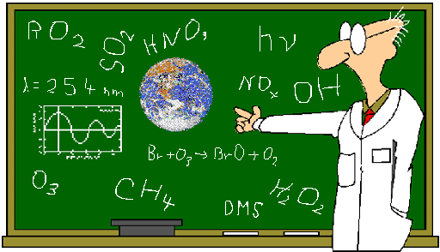

CHEMISTRY WORDS OF WISDOM
After many years of working with science and chemistry, I came up with these 3 “words of wisdom” statements.
1) Nothing is as complex as it looks or as simple as it looks.
2) The difference between trash and treasure is just the arrangement of the atoms.
3) The difference between health and sickness is just the arrangement of the atoms.
(I give more explanation of these in my oral exam study guide for my CHM130 students. If you want to read that, here is the URL to that section:
http://www.chemistryland.com/CHM130W/18-Final/OralExam/OralExam
As an extra credit problem, I will list the three Pitfalls of Learning. I will see if you can match those to their symptoms. Review the first tutorial of the semester for that information.

That’s all.

Good luck on the online exam and this on-campus exam.

Mr. C.

