CHM-107 Syllabus Spring 2016: Class 19074 (hybrid)
Welcome to Chemistry & Society
A Survey of Chemistry and its Impact on Society
Instructor: Ken Costello
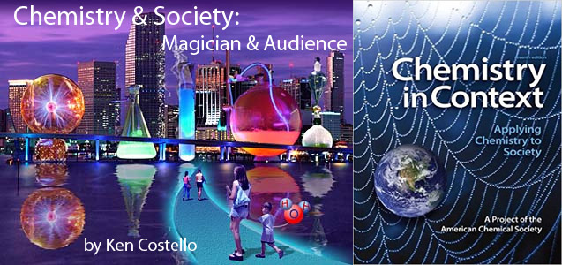
Textbooks: You will be using two textbooks: The one I've written is online (left image) and is free. The other is the 7th edition of Chemistry in Context. That one can be purchased online for $10 to $20 at Amazon. I’m using an older edition to keep the price down. Here is a link to these used textbooks on Amazon:
http://www.amazon.com/gp/offer-listing/0073375667/ref=dp_olp_used?ie=UTF8&condition=used
Course Attributes: Completion of CHM107LL is required to meet the Natural Science requirement.
General Education Designation: Natural Sciences (Quantitative) - [SQ] in combination with: CHM107LL.
Prerequisites: None.
Non-Nursing, Non-Science Majors: This class is not for students going into nursing or other science fields. Science majors could take this class but later when they take CHM130 or higher, the CHM107 class would count only as an elective. For non-science majors this is a great class to get your science with lab credit.
Course Hybrid Structure: Being a hybrid class, the class is split between face-to-face classroom time and working online. For example, this class would normally meet on campus twice a week, but because much of the content is online, we will only need to meet on campus once a week. The timed saved by not coming to a second class time is used to study tutorials online. I plan on using much of the class time for discussing course topics that are in the news.
On-Campus meeting place: Room C201. Time: Mondays, 11am to 12:20pm

Cyberspace meeting places: Chemistryland, Canvas, and Sapling Learning websites
CHM107 Home Page at Chemistryland (tutorials & reading assignments): http://www.chemistryland.com/CHM107/index.html
Canvas login page (announcements): https://learn.maricopa.edu/login/ldap
Sapling Learning website (testing): http://www2.saplinglearning.com/
Office: No office but we can make arrangements for a place to meet.
Office Hours: No set office hours, but available by email or phone all through the day (9am to 11pm) except on Mondays between 11am and 4pm while I’m in class. Mondays before 11am or after 4pm are good for setting up face-to-face tutoring or meetings at the main campus.
Phone: (480) 202-2993 (instructor’s cellphone) (602) 285-7143 (department’s administrative secretary, Rita)
Email: chm107@chemistryland.com (specific for this class-preferred).
ken.costello@phoenixcollege.edu (general email for college)
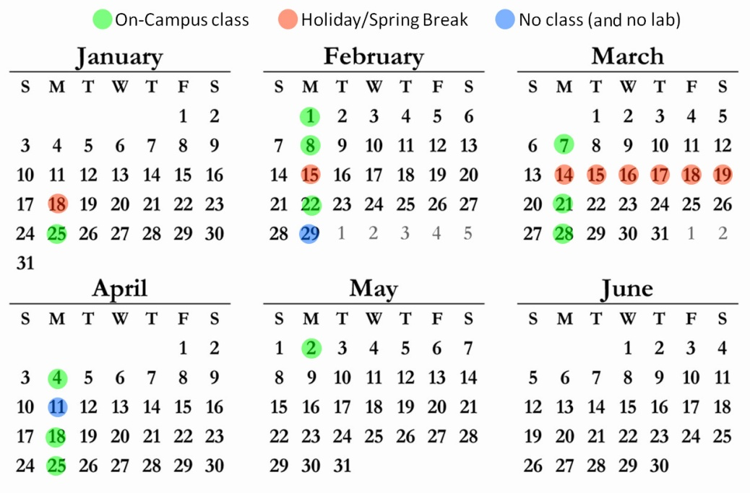
Course Schedule: The class meets on campus 11 times. There are a couple of Mondays where we won’t meet for class. That’s the same 2 days the CHM107 lab on-campus lab doesn’t meet.
Tests, Quizzes, and Grading: Being a hybrid class, I am able to have you do most of your quizzes online (using Sapling Learning) so we don’t have to use up valuable class time for quizzes. That also allows for the quizzes to be graded instantly. Instead of covering a lot of material and then having a test, I prefer that you take a quiz after every tutorial.
Scoring: I’ve taught this class online for 12 years, but this is the first time I’m offering it as a hybrid class. My previous online CHM107 course had 1600 points from quizzes, activities, and the online final. Being a hybrid course, I also want to give students points for participation in classroom discussions. One way is to give 50 points just for showing up for class. With 11 class periods, that’s 550 points. I also want you to do a report that relates “Chemistry & Society” to your major or career goal. I’ll give 200 points for that. Those all add up to 2350 points. There won’t be on-campus final, just the online final.
Grading scale: % of possible points.
A> 90 % B> 80% C> 70% D> 60% F<60% Extra credit assignments available

Course Competencies and Outline: https://archives.maricopa.edu/curriculum/A-C/992chm107.html
This is a long list of topics that I won’t show here, but these will be weaved into the tutorials and lectures.
Course Withdrawal Policy: Be aware there is a date which the Admissions Office will not accept withdrawals without the instructor’s signature.
Progress and the 45 day roster update: Around the 45th day after the semester begins, I’m required to drop anyone who is not actively engaged in their class by missing classes and not making satisfactory progress on the Sapling Learning quizzes.

Student Guide: All Maricopa Community College students are expected to be familiar with the Student Guide that explains the policies, procedures, and resources for students. Here is the web address for the Student Guide.

https://legal.maricopa.edu/student-guide-policies-procedures-and-resources
Besides student responsibilities, it has a wealth of other information, too.
Disability Support Services: If you have or think you have a disability, including a learning disability, please make an appointment with an advisor or the Disabilities Resources and Services center as soon as possible (tel. (602)285-7477, fax. (602)285-7663, video phone (623)208-4063). You will be assisted with appropriate accommodations in your classes.
Dive In: In summary, I think this class is valuable and enjoyable at the same time. Learning chemistry is like traveling to new places and seeing things you didn't know existed.

